**Inventory Management System**

Simple mini project for managing the stock master, stock out, return stocks, etc.

User will handle the stock manager, the user must enter the name, description, type, price, and quantity of the items.

After this, the user can manage stock out, return by entering the customer id, transaction id, name, address and adding items. From settings, he/she can add categories and item unit.

User can manage stock out, return by entering the customer id, transaction id, name, address and the items added. From settings, he/she can add categories and item-unit.

This system’s last feature about the user management system, where the admin can add and arrange various user roles.

While operating on it the user will not encounter difficulties.

Assists the user in managing the recording of stock items. MySQL is used as a database for handling the data.

This project is user friendly to run and understand.

To be more specific, the system helps keep track of inventory in relation to how much it has sold. Also, the system shows which items have been paid for and which have not.

The system also lets you manage system users and do more. This project seems to have both a manager panel and a customer panel.

In a broad sense, an admin has full control over this web application. He or she can handle sales, employees, and inventory.

**Manager Dashboard**

A manager’s account also gives them access to all of the inventory activities. Here, a manager can add, change, remove, and list the inventories of a company. In reality, the system lets you keep track of sales records.

For the system to be able to manage inventories, it needs details like the name of the model, the parts, the type, and the price. The manager or administrator is also in charge of keeping track of how much of each item is in stock.

Also, the system takes the amount of a product away automatically as soon as it goes through the transaction process. Also, the manager can make a variety of PDF reports. It has the report on orders, item lists, and more.

**Customer Dashboard**

On the other hand, users can just sign up for the system. Here, the system lets customers search for products based on general information about them.

A customer can also look for the products they want and add them to their cart.

And once the user is done adding items to the cart, he or she can go to checkout.

Also, the customer has to look at the product before confirming the order.

And once the orders are confirmed, the records are moved to the manager’s “unpaid orders” section. Customers can also see all of their orders and cancel them if they need to. To be more specific, the whole system is much easier for customers to use to filter products and place orders.

**Features**

* Login System
* Manage Stock master, out, return
* Generate Report
* Settings
* User Management System

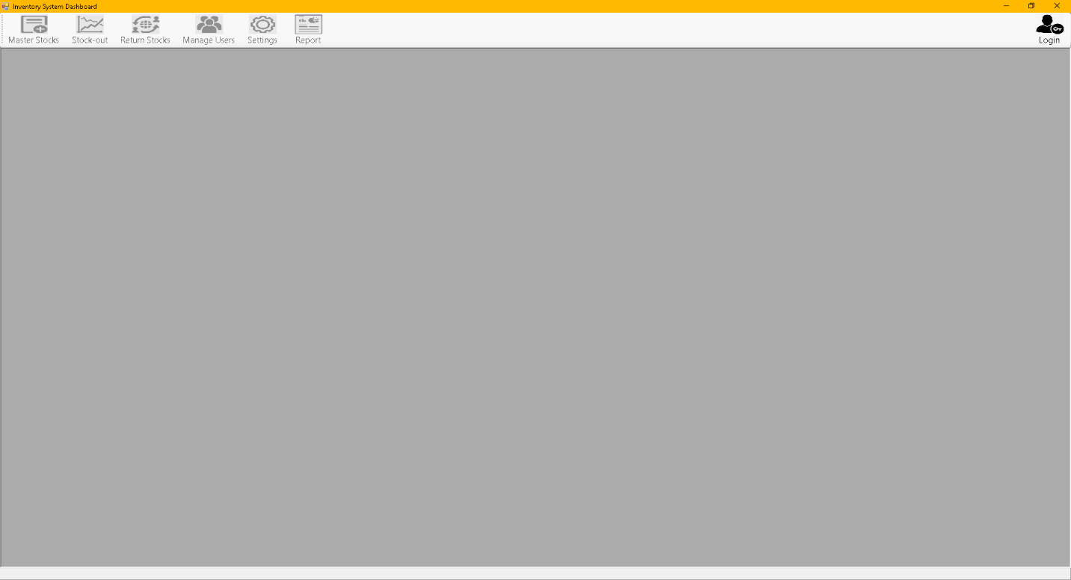**User Interface/Dashboard**

**Login Page**

Authorized person only to manage the inventory

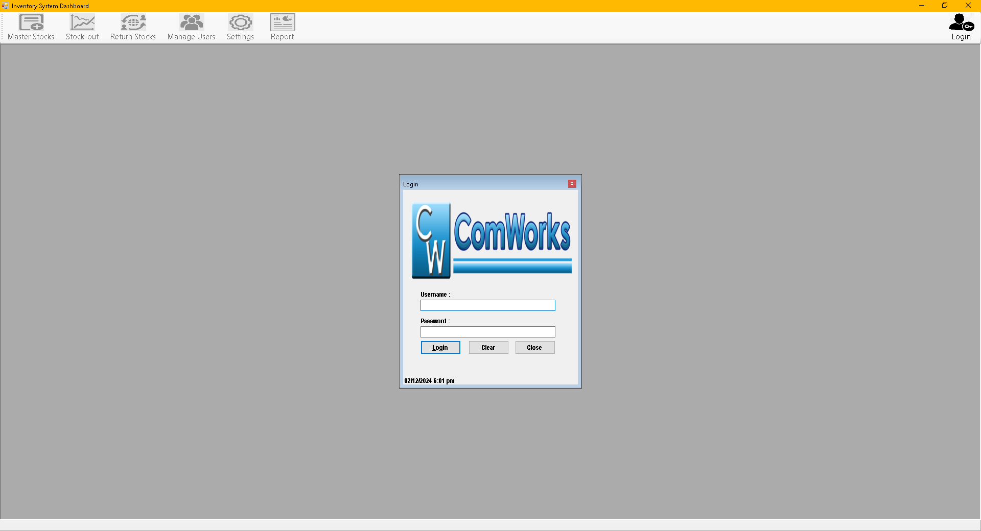

**The Master Stocks**

Where all the stocks delivered from the store are being stored with **Save, Update, Delete, New and Close Button.** Input the **Item name, the Description, Category, Price, and Quantity by Pieces**

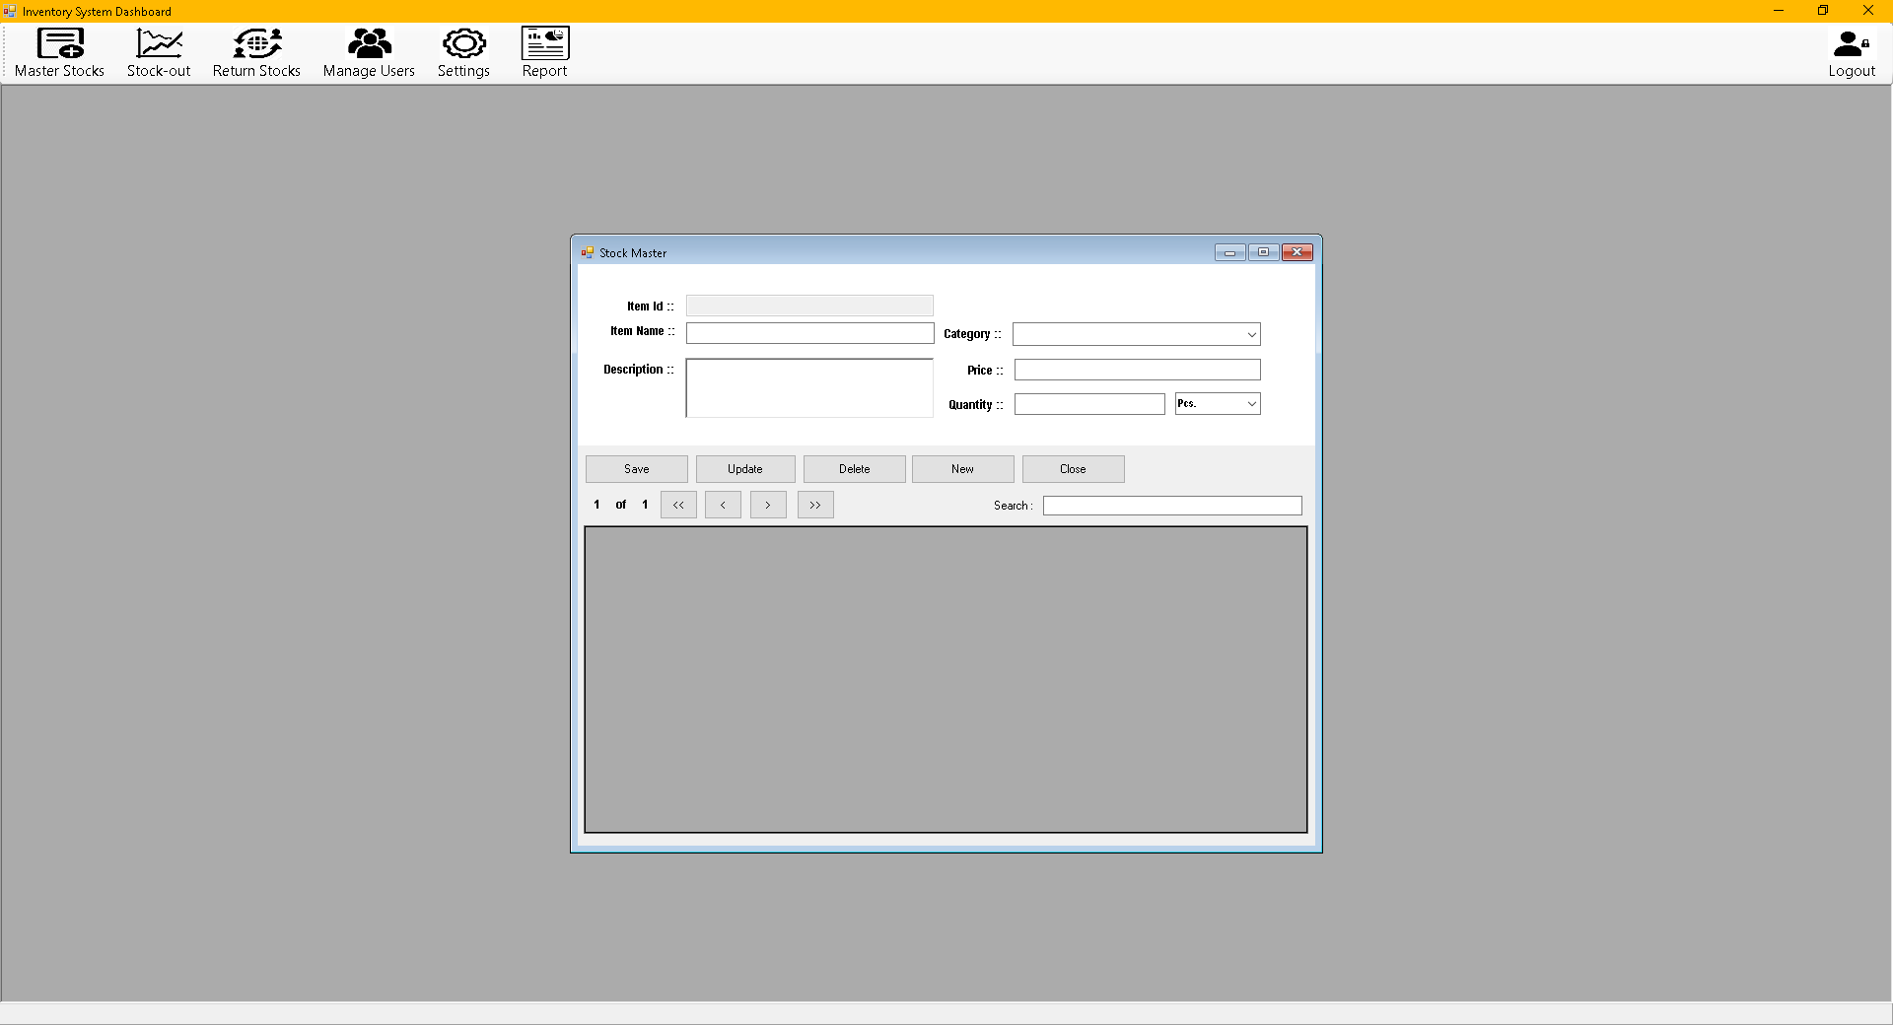

**The Stock-out**

Where out going stocks being sold or delivered to another store is being handled with **Customer ID, First Name and Last Name of the Customer. List of Products** with **Search Bar. List of Added Items** with **Item Id, Item Name, Description, Price, Quantity** and **Total Price.** With **Save, Remove, Clear, View List and Close Button.**

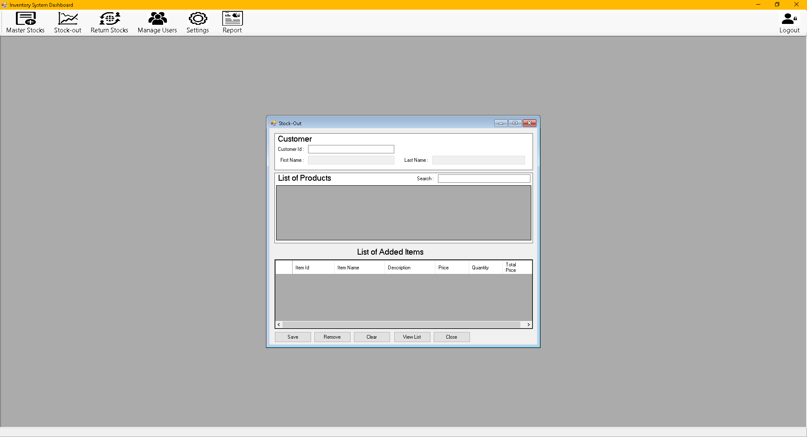

The **Return Stock Dashboard** similar with Stock Out Dashboard where stocks are being returned to the previous store are being handled.

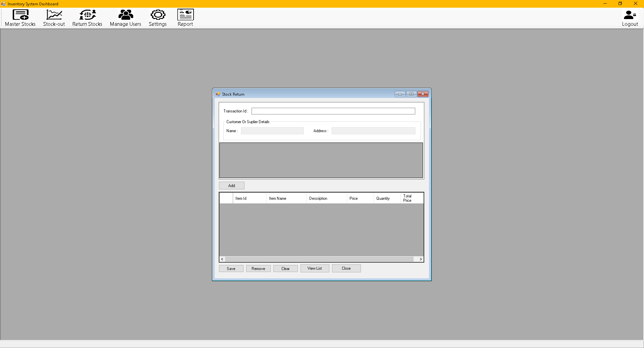

The Manage Users Dashboard where authorized personnel should create their unique **username** and **password** in order to manipulate and manage the **Inventory Management System.** It can create multiple users, **update and delete users** from the system. Can also choose the type of **user** if it is **Administrator** or **Staff.**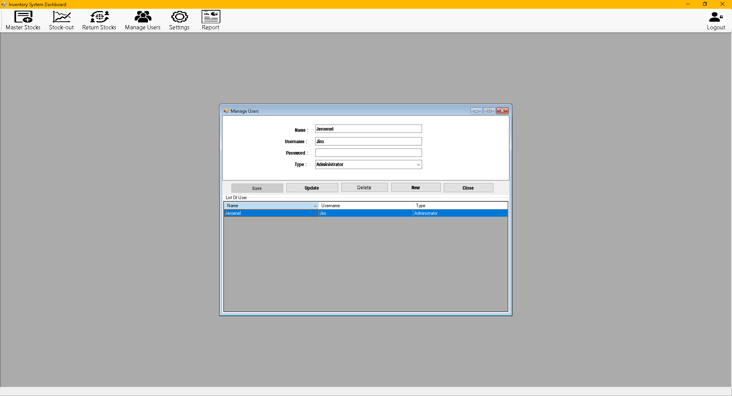

The **Settings** Menu where we can **Add new Category Save, Update, Delete** and **Load** all the Categories of the stocks from the store e.g **Smartphones, Accessories, Laptops ad Tablets.** And **Add New Item Unit** if it is per **Pieces, Boxes, Meters** or **Kilo.**

